**Experiment No. 1.1**

**Student Name: Rishav Kumar UID: 22MCC20039**

**Branch: MCA - CCD Section/Group: MCD-1/ Grp A**

**Semester: IV Date of Performance: 18th Jan 24**

**Subject Name: CI/CD Pipelines Subject Code: 22CAP-781**

1. **Aim/Overview of the practical:**

a) Create a python file named as your UID (eg.22MCC20001.py) with some code inside it on a Local Repository named as your UID (eg. 22MCC20001). Push this file on Remote Repo.

(b) Create another Local Repository named as your name (eg. ABC) and pull the files from Remote Repo in it. After this, create a new file in new Local Repo i.e. ABC and push it to Remote Repo. Again pull the files on old Local Repo i.e. 22MCC20001.

(c) At last, visit Remote Repo and commit some changes in a file created i.e. 22MCC20001.py and pull the file again in new Local Repo i.e. ABC. Check whether the changes are existing in file in Local Repo or not.

1. **Code for practical:**

**A)**

* Open command prompt or git bash.
* Create a folder using command ***mkdir 22MCC20039***
* Change directory using ***cd 22MCC20039***
* Initialize git using ***git init***

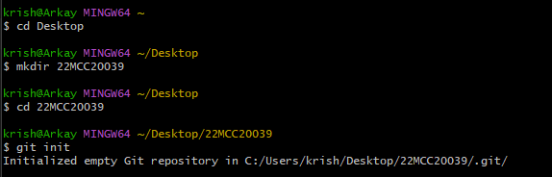

* Create a new file using ***notepad 22MCC20039.py***
* Check ***git status*** after that add file using ***git add 22MCC20039.py***
* After that, again check status of git.

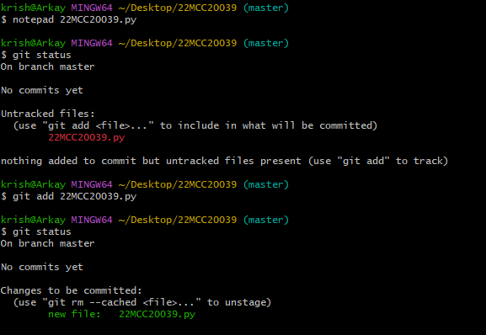

* Commit changes using ***git commit -m “Message”*.**
* Add username and email on git using

***git config user.name "Username"***

***git config user.email “emailaddress@gmail.com”***

* Open ***Github.com > Repositories > New***
* Now create a new main branch using ***git branch -M main***

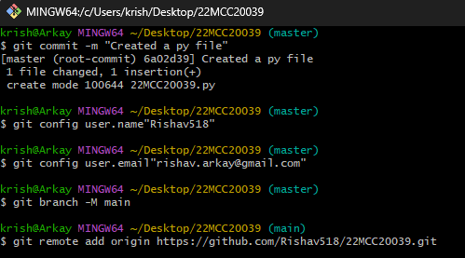

* Connect remote repo using ***git remote add origin <repo_link>***
* Now push local repo to remote repo using ***git push -u origin main***.

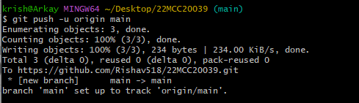

**B)**

* Create another folder using ***mkdir rishav***
* Initialize git by using command ***git init***
* Add remote repo ***git remote add origin*** [***https://github.com/Rishav518/22MCC20039.git***](https://github.com/Rishav518/22MCC20039.git)

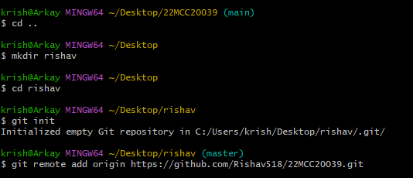

* Now pull from remote repo using ***git pull origin main***

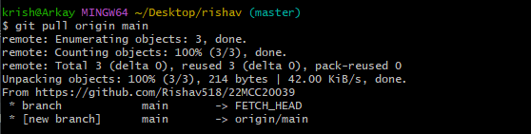

* Now create a second file and add it on git.
* Commit changes to local repo.

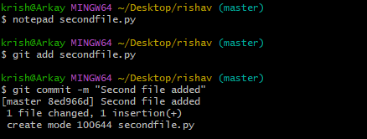

* Now, push changes to remote repo using ***git push -u origin master***

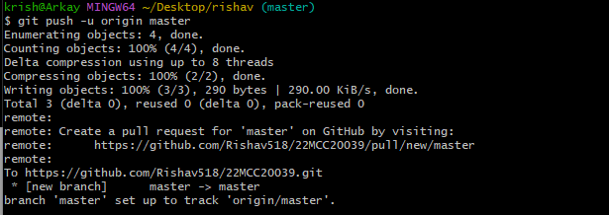

* Change local repo to first directory 22MCC20039 and use pull command.

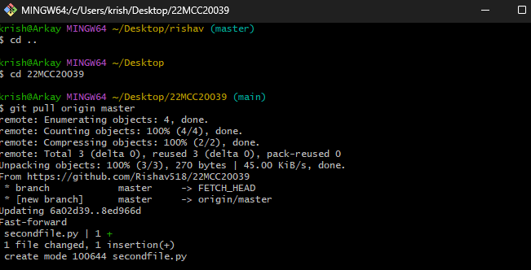

* Open GitHub and make changes in first file i.e. 22MCC20039.py
* Go to second local repo and pull the file.

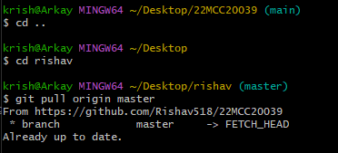

* Changes has been made in the file present in local repo.

**************************************** **THE END** ***********************************************